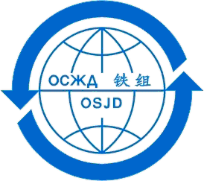


Company code update form
Please type or print in dark ink

N.B. tick the right case and fill out – indicate clearly what has to be changed

Withdrawal of one or more codes
Code(s) to be cancelled:

Update of company data
Company name:
Short name:
Full address:
Principal activity of the company
Officer responsible:
Phone:
E-mail:
VAT number (if inside the EU) :

Update of code utilisation data
Code utilisation:
Comments :

Name:
Date: Signature:
This update form should either be:
- send by post to the following address: International Union of Railways (UIC)
Allocation of Company Codes
16, rue Jean Rey
F - 75015 Paris or
- send by e-mail to: oca@uic.org

